**Data Structure LAB #4 Homework**

**[H/W 4-1]**

Make Stack and Queue based on Double Linked List

This homework will provide pre-structure codes with API document.

But you can make your own code without pre-structure codes.

**<Caution>**

1. If you use pre-structure codes, you must keep original file name.
2. You must keep output format like sample output.
3. If you make your own code, make function explain word report file like API document.

**<Output> - Sample**

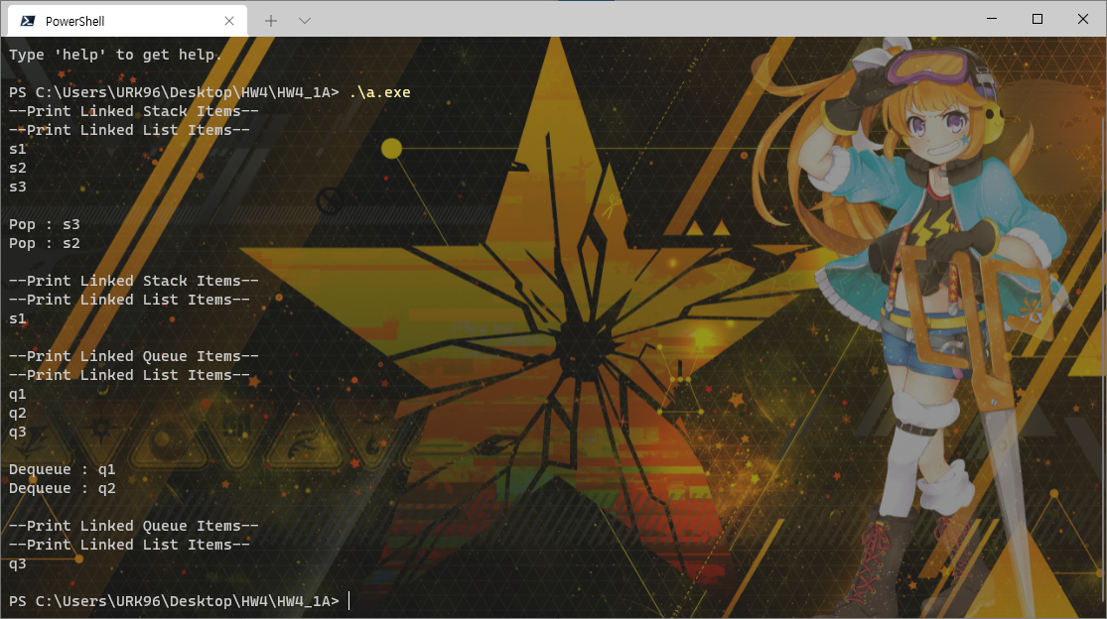

**[H/W 4-2]**

Implement Sorted Double Linked List.

Implement **insert & remove** function of Sorted Double Linked List

Sort Type : **Ascending** (If the two value is same, the operation is same as when the input item is bigger than list item)

**<Output> - Sample**

